**Project Report**



School of Computer Science and Engineering

Lovely Professional University.

Phagwara, Punjab (India).

**INT404 – ARTIFICIAL INTELLIGENCE**

Submitted to:

Sagar Pande sir

Submitted By:

|  |  |  |  |  |
| --- | --- | --- | --- | --- |
| Name | Registration Number | Roll No | Email-Id | GitHub Link |
| **Motupalli Sai Lohith** | **11801913** | **13** | sailohith1439@gmail.com | <https://github.com/Motupallisailohith/vehicle-detection-using-python-libraries> |

**VEHICLE DETECTION AND CLASSIFICATION**

**Abstract:**

Traffic Analysis has been a problem that city planners have dealt with for years. Smarter ways are being developed to analyze traffic and streamline the process. Analysis of traffic may account for the number of vehicles in an area per some arbitrary time period and the class of vehicles. People have designed such mechanism for decades now but most of them involve use of sensors to detect the vehicles i.e. a couple of proximity sensors to calculate the direction of the moving vehicle and to keep the vehicle count. Even though over the time these systems have matured and are highly effective, they are not very budget friendly. The problem is such systems require maintenance and periodic calibration. Therefore, this study has purposed a vision based vehicle counting and classification system.

**Related work:**

1. This is a simple vehicle Detection, counting and classification program
2. Here I used background subtractions methods of OpenCV Library of Python and morphological transformation.
3. Here we defined a vehicle class named as Vehicle which was imported in main programme.
4. Them myMorphing python code is scripted to transform binary images using erosion method, it erodes away the boundaries of foreground object (Always try to keep foreground in white).

**Implementation:**

1.The first step of the proposed system is to grab a data on which we want to perform the classification.

2. After video selection, ROI is defined. ROI needs a careful human supervision because

region of interest and imaginary line plays important role in classification.

1. After ROI is defined, the system performs series of tasks i.e. applying background mask, subtracting mask, performing binary threshold, morphology using erosion and dilation, median blur, applying masked data to the frame, convert frame to gray scale.
2. Contours are detected after these operations. Once contours are detected; system analyses the moments of the contours, marks the detected contours and centroid is calculated. If calculated centroid is in the range of the diagonal system .
3. It moves towards further operation for classification else system will be
4. redirected towards the detection of contours again.
5. The last step is the classification; the system classifies the vehicles with two different methods i.e. using SVM and the cc.

**SnapShots:**

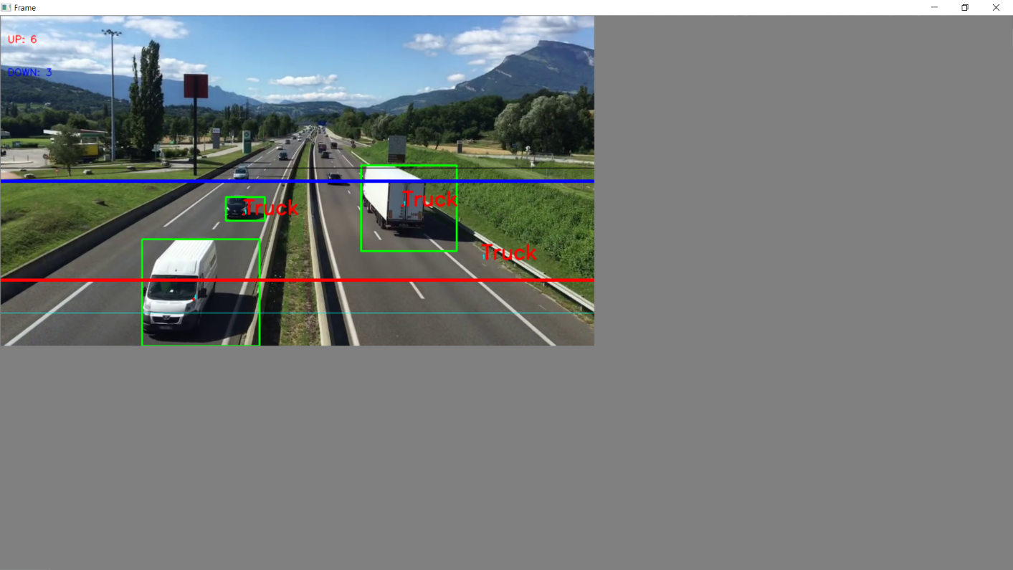

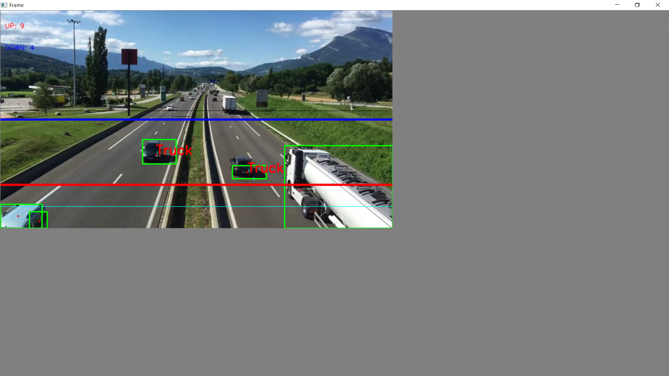

**Important libraries used:**

OpenCV:

 OpenCV-Python is an appropriate tool for fast prototyping of computer vision problems.

numpy:

NumPy is the fundamental package for scientific computing with Python. It contains among other things:

* a powerful N-dimensional array object
* sophisticated (broadcasting) functions

**References**:

* <https://www.researchgate.net/profile/Sania_Bhatti/publication/327554338_A_Video_based_Vehicle_Detection_Counting_and_Classification_System/links/5bd9310492851c6b279b95d3/A-Video-based-Vehicle-Detection-Counting-and-Classification-System.pdf>

a research paper based on vehicle detection and classification.